CIRCUIT DIAGRAM AND CODES OF MODERN DETECTION SYSTEM IN FRITZING

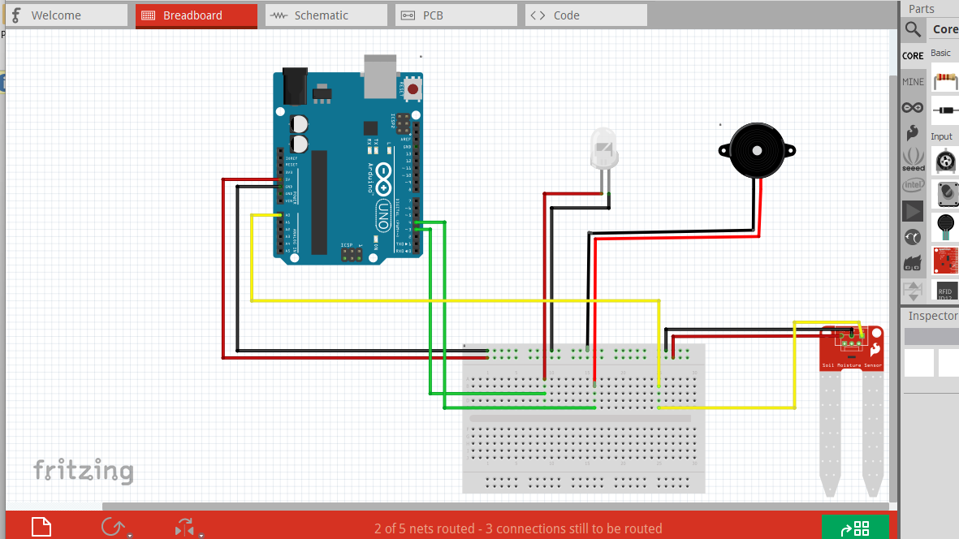

CODES:

int moisture_sensor=A0;

int led=3;

int buzzer=4;

void setup ()

{

Serial.begin(9600);

pinMode(moisture_sensor,INPUT);

pinMode (3, OUTPUT);

pinMode (4, OUTPUT);

}

void loop ()

{

int level;

level=analogRead(A0);

Serial.println("analogvalue:");

Serial.println(level);

DigitalWrite (3, LOW);

DigitalWrite (4, LOW);

if(level<1000) {

digitalWrite (3, HIGH);

digitalWrite (4, HIGH);

}

}

